**IS 456 IT Database Systems Management**

**Programming Exercise 2**

4/13/2021 Developed by Farzin Bahadori

School of Technology & Computing @ City University of Seattle (CityU)

Using Chinook Database: (**Database is available in GitHub repository under db folder)**

## Task 1:

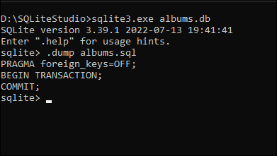Using the Command prompt, create a backup file as a sql text-file, for the albums table, name it as albums.sql. [Use Dump Command]. take a screenshot and submit it.

## Task 2:

1. Write a SELECT statement that will return the records, and titles columns from the albums table.
2. Filter the results to include only the customers from the country Brazil.
3. Execute the written statement.
4. ***```SQL***
5. **SELECT** albums.*AlbumId* **AS** Records, albums.*Title*
6. **FROM** albums
7. **JOIN** tracks **ON** albums.*AlbumId* **=** tracks.*AlbumId*
8. **JOIN** invoice_items **ON** tracks.*TrackId* **=** invoice_items.*TrackId*
9. **JOIN** invoices **ON** invoice_items.*InvoiceId* **=** invoices.*InvoiceId*
10. **JOIN** customers **ON** invoices.*CustomerId* **=** customers.*CustomerId*
11. **WHERE** customers.*Country* **=** 'Brazil'
12. **ORDER BY** 'Records' **DESC**;
13. ***```***

## Task 3:

1. Write a SELECT statement that will return First and last names, company, address, phone and email address of customers from the Customers table.
2. Filter the results to include only customers from the countries Canada and USA.
3. Execute the written statement.

